PRESS RELEASE

Kubota to showcase versatile mowing and powerful compact tractor performance at SALTEX
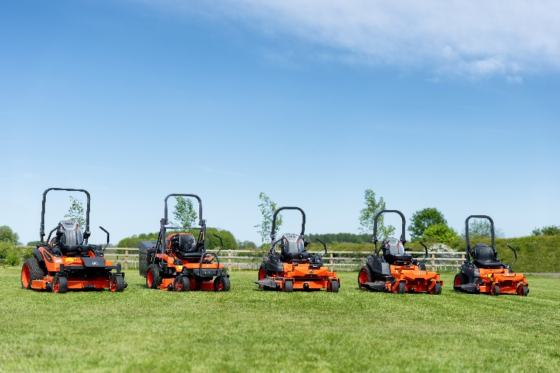

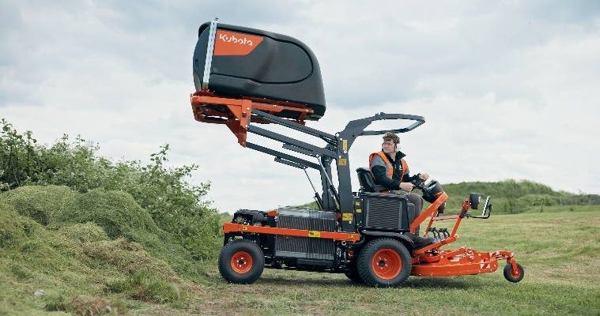
No trip to SALTEX would be complete without a stop at the Kubota stand, with E060 this year offering visitors a comprehensive showcase of compact tractors and innovative mowing solutions to suit all situations. The stand will once again be shared with Baroness, bringing together two complimentary Japanese manufacturers to deliver one impressive line-up of equipment critical to successful sports turf maintenance.

At the heart of Kubota’s SALTEX offering will be the FC Series of out-front centre collect mowers. Designed to provide professional operators with a highly versatile cut and collection solution, the FC range combines excellent productivity and manoeuvrability with a wide range of optional attachments and implements - allowing the machines to be configured for a variety of applications beyond mowing and helping to maximise machine utilisation throughout the year.

Kubota will also highlight their expanded zero-turn range, offering even greater choice for facilities that demand the very best in productive rotary mowing. With petrol, diesel and battery-powered options available, Kubota’s zero-turn machines are ideal for amenity applications thanks to their ability to negotiate obstacles and confined areas while maintaining high mowing speeds and a precision finish.

Completing the display will be an impressive selection of industry-leading compact tractors to suit all applications and all budgets. The entry-level EK1-261 will once again demonstrate Kubota quality in a package ideal for grassroots sports facilities, while machines from the popular L-Series promise to reaffirm why the brand remains a dependable workhorse for everything from routine maintenance to more demanding, specialist tasks.

Visitors are invited to discover more in conversation with the Kubota team, supported by the Kubota dealer network, who will be on hand at the NEC throughout the two-day event.

ENDS

About Kubota Corporation
Kubota has been a leading manufacturer of agricultural equipment, construction equipment, lawn mowers and industrial engines since 1890. With its global headquarters in Osaka, Japan, offices in more than 120 countries and more than 41,000 employees in North America, Europe and Asia, Kubota had a turnover of $20 billion in 2021. Although agricultural, construction and turf equipment are its main product lines, Kubota also produces a wide range of products such as city water purification systems, irrigation systems, piping systems, roof and home construction, and large underground valves.

Our Mission
Our mission "For Earth, For Life" speaks to our commitment to the conservation of the environment while aiding the production of food and water supplies, which are vital to meet the needs of our society, as the world’s population continues to grow. This mission is accomplished every time a Kubota tractor harvests the land to produce food or when our construction equipment excavates to transport water or provide shelter.

For more information about Kubota, visit www.kubota-global.net / www.kubota-eu.com /
Explore the Kubota Group Solutions Hub: https://kubota-group.eu

For further information please contact:

Charlotte McFarland, Tactical Marketing Executive,

Kubota (UK) Ltd, Dormer Road, Thame, Oxfordshire OX9 3UN

Tel: +44 (0)1844 214500

E-mail: charlotte.mcfarland@kubota.com

Issued by Louise Challiss, PAN Publicity Ltd
Tel: +44 (0)1493 440047
E-mail: louise@panpublicity.co.uk
PR Ref: 12764

Date of issue: 3rd September 2026



Follow us on:
Website: https://www.kubota.com , https://www.kubota-eu.com
LinkedIn: https://www.linkedin.com/company/kubota/, https://www.linkedin.com/company/kubota-in-europe/
Facebook: https://www.facebook.com/KubotaEurope/
Youtube: https://www.youtube.com/channel/UC2T6NyJ2cAvVPss9Lx7hBhQ

