Efficiency takes centre stage for GKB at SALTEX

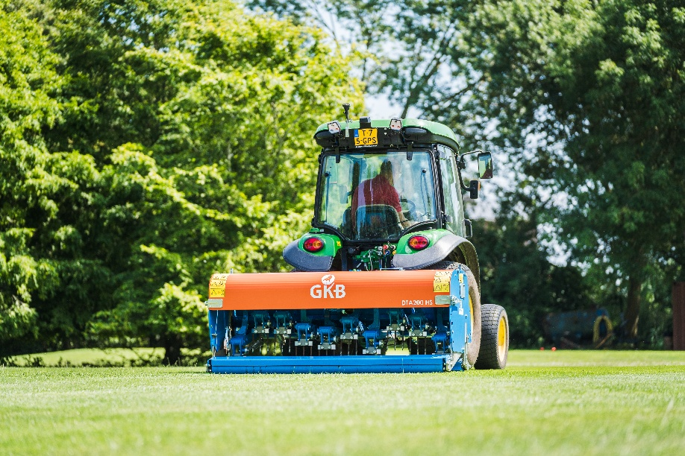
With time being an evermore precious commodity to grounds managers, GKB will be putting the focus firmly on efficiency with their product line-up at SALTEX 2026. Launched earlier in the year, and already proving its efficiency credentials with operators across the country, the Deep Tine Aerator High Speed (HS) promises to be a particular highlight of stand B120.
The most recent addition to GKB’s aeration portfolio, the Deep Tine Aerator HS combines high productivity with the robust build quality for which GKB is renowned. Available in 1.2m, 1.6m and 2.0m working widths and with a 3kph working speed, the machine promises superior output without compromising aeration depth or quality - bringing compaction relief of up to 250mm to sports pitches, cricket outfields and racecourses along with smaller areas such as greens and tees.
Exclusive to GKB, the HS model is equipped with a two-speed gearbox, enabling the operator to quickly and easily switch between fast, shallow aeration of the top layer or slower, deeper compaction relief when conditions demand. Further efficiency is brought by the unique tine block mounting system, featuring three 12mm tines or two 18mm tines on one block, significantly reducing the time and complexity of switching between sets.
Visitors looking for high-quality solutions to synthetic surface maintenance will also be catered for on stand A080, with GKB’s popular Deep Clean on show. Launched at SALTEX 2025, the latest iteration of the Deep Clean offers efficient removal of dirt, dust, contaminants and other unwanted particles from all types of artificial turf. Three model widths are available from 1.2m to 1.8m, all providing quick setup and easy operation to keep pitches clean, safe and in optimal play condition.
UK Operations Manager Tom Shinkins will be joined on stand by GKB’s new UK & Ireland Sales Manager Dougie Archibald, both on hand to answer all of your maintenance and machinery questions. So, this November, be sure to stop by, say hello and find out more about the full range of equipment for all types of surface and discover solutions for all turfcare operations throughout the maintenance calendar.
ENDS

