Baroness to bring precision, performance and versatility to stand E060 at SALTEX

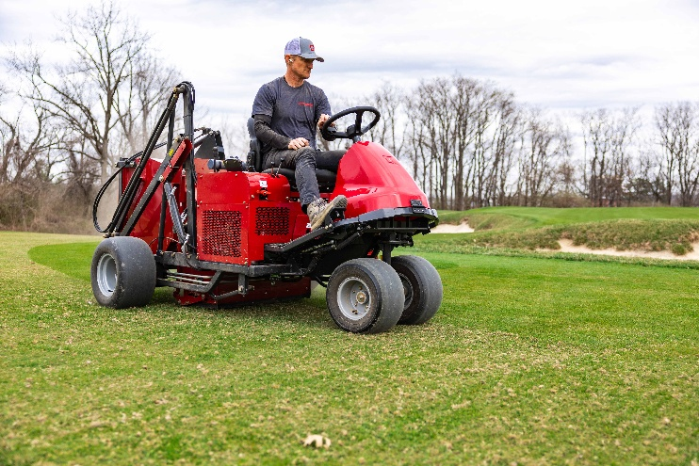
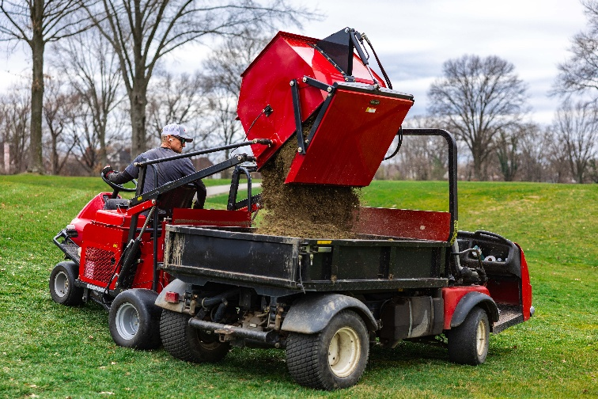
Baroness will showcase its renowned range of industry-leading mowing technology at SALTEX 2026, with an extensive line-up of rotary and cylinder mowers taking centre stage on stand E060. Visitors will have the chance to explore leading solutions for maintaining fine turf and sports surfaces, including the company’s premium GM2810A five-deck ride-on mower, alongside a selection of robust and reliable equipment ideal for renovations and in-season maintenance.
The popular Baroness GM2810A is equipped with five rotary decks that individually follow undulating terrain, delivering a quality cut and a precision finish on a variety of areas. It’s 2.8m mowing width enables high productivity, while a large displacement turbo clean engine and unique hydraulic circuit drive system provides first-class climbing capacity and unmatched performance on banks and slopes. Complimenting this on stand will be the LM351 – a flexible, well-balanced triplex cylinder mower with the power to cut longer grass and the finesse to produce a superior finish – and the pedestrian LM56/66 machines.
At the heart of every Baroness reel mower is the cutting cylinder and bedknife, with every cutting cylinder individually balanced and heat treated for longevity and a cut which stays sharp and true.
With leaf-fall season just around the corner, SALTEX also provides the perfect platform to showcase the AgriMetal Turbine Blower TB-270. Equipped with an aluminium cast turbine propeller, the TB-270 provides a long-lasting solution to the fast and effective clearance of leaves and other debris from golf courses, sports facilities and other amenity green spaces.
Completing the display will be the FS900 sweeper/collector. Not only is the FS900 the perfect partner to time-critical golf course renovations – quickly lifting and removing scarification material, cores and other maintenance debris – it is also proving a highly productive alternative to the traditional rotary mower when it comes to the post-match ‘clean-up cut’ on sports pitches.
Stand E060 will once again be shared with fellow groundcare leaders, Kubota, providing visitors to SALTEX with a unique opportunity to experience the complimentary capabilities of two Japanese manufacturers whose products are built around precision, reliability and performance.
ENDS

