BAGMA Training for Business to launch on stand A030 at SALTEX 2026

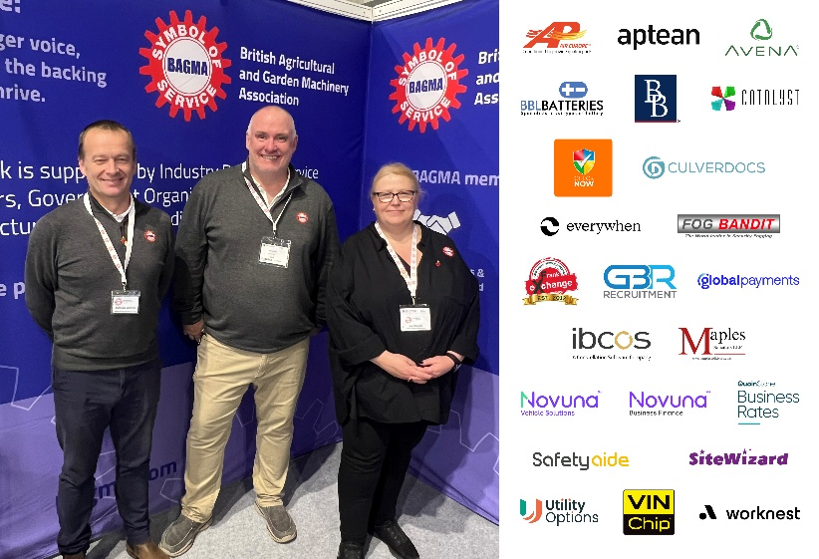
Training will be top of the agenda for The British Agricultural and Garden Machinery Association (BAGMA) on their return to SALTEX this November. Stand A030 will be the launch platform for ‘Training for Business’, with members invited to stop by and find out more about a brand new, powerful range of learning and development resources designed specifically for dealership owners, managers and staff.
BAGMA has a long and illustrious track record for providing industry-leading training and development programmes. Reflecting the extensive industry changes and the increasingly challenging market within which dealerships operate, BAGMA has teamed up with education leaders and experts within their Service Provider network to develop a series of training programmes which cover key topics including succession planning, aftersales and the key to building a competitive, sustainable dealership.
The new Training for Business programme will run alongside BAGMA’s existing educational offering, which includes Handover & Installation training and the industry’s first EV training – a one-day programme to help technicians, sales staff, delivery drivers, engineers and workshop personnel gain a working knowledge of the hazards of high-voltage electric systems, best practice for handling and storage of battery packs and an awareness of all relevant legislation and compliance requirements.
BAGMA are pleased to be hosting a seminar on the topic of EV Safety as part of SALTEX’s Learning LIVE programme this year – a free to attend session taking place at 2pm on Wednesday 11th November on the Community Sports Stage.
Following this at 3pm on the first day, the BAGMA team will also be hosting an exclusive Connect event in The Clubhouse, sponsored by Iseki, with members invited to join peers, industry partners and a selection of BAGMA Service Providers for a drink.
If you’re wondering if BAGMA membership could help your business, stand A030 is the place to find out more about training, discounts and the other member benefits available when SALTEX returns to the NEC, Birmingham, on 11th-12th November 2026.
ENDS

