ATT build momentum ahead of SALTEX Showcase

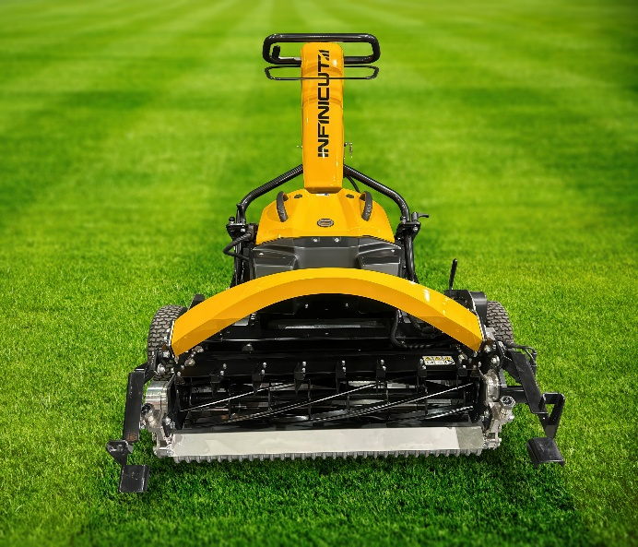
An exciting year for Advanced Turf Technology (ATT) - which has seen the company’s re-acquisition to its original ownership and recent expansion of the UK sales force - will culminate in an impressive machinery showcase at SALTEX. Visitors can expect to see highlights from the INFINICUT® range, including the FX347 and SM34 Rotary mower, alongside the full collection of TMSystem™ maintenance cassettes on stand C110.
Following the buy back in February 2026, John Coleman and new company Chairman David Withers have been working tirelessly to reaffirm the INFINICUT’s position as a leading force in the global mower market. With a new Sales Manager in Jeremy Vincent and a move to new dedicated manufacturing premises earmarked in the coming months, the team are well placed to support the existing range and customer base and accelerate innovations and new products currently in the development pipeline.
Highlights from the current INFINICUT® range will take centre stage at the NEC this November, including the FX347. The latest addition to the cylinder mower collection, the FX347 is a fixed head, 34” pedestrian mower equipped with 7” diameter cutting reel, ideal for training grounds and other premium sports turf facilities. As has become expected with INFINICUT®, the FX347 delivers industry-leading cut quality, ergonomic control and ease of set-up and adjustment via the InfiniApp™.
The ATT technical team will also be on hand to talk visitors through the TMSystem™ range of grooming, mowing and maintenance cassettes. Unlocking the full potential of your INFINICUT® pedestrian unit or most mainstream models of ride-on mower, the TMSystem™ range features 12 application specific cassettes that replace OEM cutting reels and deliver optimum maintenance results on both fine turf and sports turf surfaces.
Get all of your INFINICUT® and maintenance questions answered with a stop by stand C110 when SALTEX returns on 11th and 12th November 2026.
ENDS

