Suståne to showcase solutions for more resilient surfaces at GroundsFest

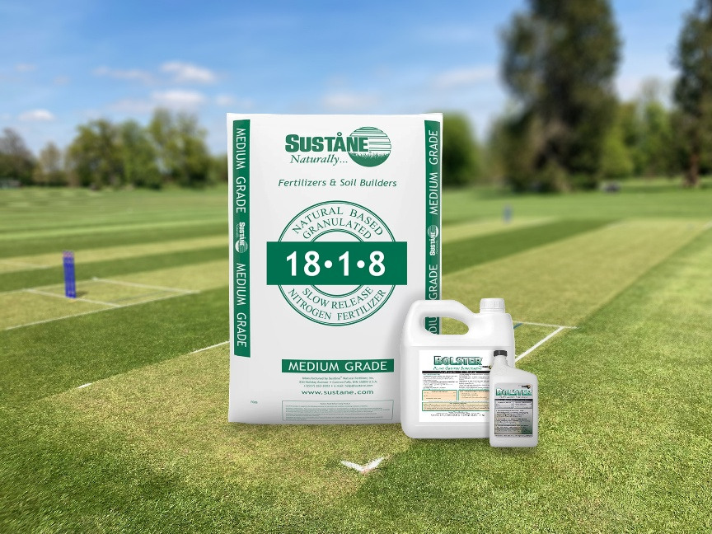
Visitors to GroundsFest 2026 looking for sustainable nutrition and plant health solutions will find all the answers with a stop by Suståne Natural Fertilisers on stand 44. This year, the focus will be on two products designed to deliver long-lasting performance across amenity and landscape turf: Suståne 18-1-8+Fe and Bolster Liquid Plant Biostimulant.
18-1-8+Fe combines controlled release fertiliser technology with Suståne’s natural organic compost base to provide up to 16 weeks of consistent nutrition and support long-term soil health. The formulation features three slow-release nitrogen sources and one quick-release form to deliver a steady supply of nutrients without the flush of growth sometimes associated with conventional fertilisers.
This even, controlled growth makes Suståne 18-1-8+Fe ideal for golf courses, sports turf, parks, lawns and amenity landscapes – creating turf with excellent colour and reliable performance. Its near-neutral pH, low salt index and low ammonium content also make it exceptionally safe to use, helping to minimise the risk of scorch while supporting beneficial soil biology through the addition of stable organic matter and humates.
Complementing the granular fertiliser is Bolster Liquid Plant Biostimulant – a product specifically formulated to help turf and ornamental plants cope with environmental stress. Containing 5% chelated iron, 4% humic acid and 2% seaweed extract, Bolster is designed to enhance root development, improve chlorophyll production and strengthen plants against drought, temperature extremes, poor soils and other environmental challenges.
Proven to improve root mass and depth, moisture retention and overall plant resilience, Bolster can also be tank-mixed with most fertilisers making it easy to integrate into the maintenance programmes of grounds professionals managing sports facilities, public green spaces and landscaped areas.
The Suståne team will be on hand throughout GroundsFest to offer practical technical advice and tailored recommendations whether your objective is to improve soil health, overcome environmental stresses or develop a more sustainable programme to achieve healthier, more resilient surfaces.

