Take on the TinyMobileRobots challenge to win big with Origin Amenity at GroundsFest
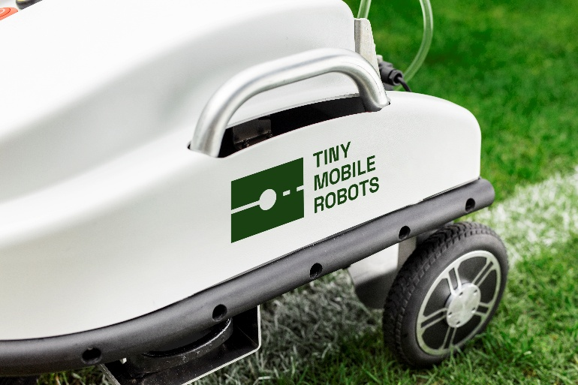
Origin Amenity Solutions (OAS) will be among the must-see exhibitors at this year’s GroundsFest, bringing one of the industry’s most comprehensive portfolios of products, services and technical expertise to Stoneleigh Park. Visitors to stand RB140 will be able to explore innovative solutions for the landscape and amenity sectors, designed to deliver improved efficiency, sustainability and green space quality.
Alongside the many well-known products from their comprehensive range, GroundsFest 2026 will also be the launch platform for a number of new OAS products including Eco Ice Melt – a premium de-icing solution to effectively control ice with reduced corrosion and improved longevity compared to traditional rock salt. Offering lower application rates and improved spreadability, one bag of Eco Ice Melt can successfully treat areas of 1000m² in temperatures as low as -20ºc helping to maintain safer surfaces during severe winter weather.
Another stand focus will be FleetKleen, Origin’s specialist vehicle cleaning range designed to keep fleets operating at their best with professional-grade cleaning and maintenance solutions.
Innovation will also take centre stage with a spotlight on the TinyMobileRobots range. Proven to transform line marking operations through precision automation, the TMR range is an increasingly popular choice for contractors, schools and sports facilities looking to improve both the productivity and accuracy of their marking.
Adding to the excitement, visitors will have the chance to test their skills on a TinyMobileRobots obstacle course challenge, taking place across the two days. Alongside bragging rights, the lucky winner will earn themselves an exclusive trip to the TinyMobileRobots factory in Aarhus, Denmark, offering a behind-the-scenes look at the technology driving the future of robotic line marking.
With proven products, innovative technologies and the expertise of our trusted technical team, OAS remains a dependable partner for those shaping, maintaining and improving the nation’s amenity and infrastructure landscapes. Pick up a brochure to discover more about plant protection, fertilisers, specialist seed, line marking, sports equipment, essential sundries and more when GroundsFest returns on 16th and 17th September 2026.
ENDS

