PRESS RELEASE

Kubota to showcase machines for all maintenance tasks at GroundsFest 2026

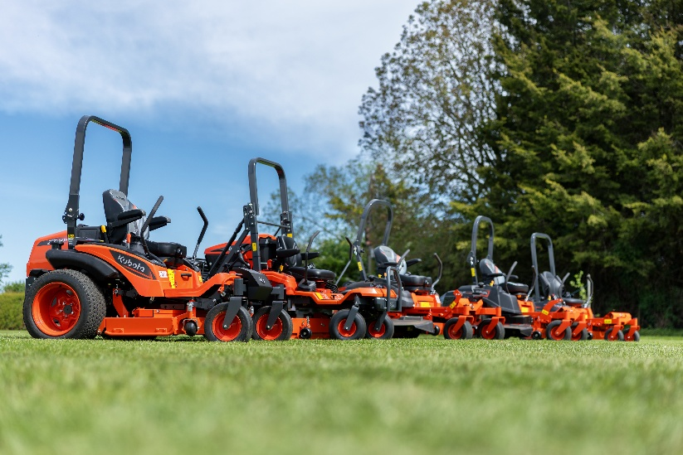
A stop by stand OSA810 will be a must for visitors to this years GroundsFest, with Kubota and Baroness joining forces to showcase one of the industry’s most comprehensive equipment line-ups. While many stands will focus on a single equipment category, Kubota’s attendance will highlight the depth and versatility of their range, designed to support grounds professionals, landscapers, contractors and local authorities across multiple environments and maintenance operations.

Attendees will have the opportunity to get up close with the latest innovations in the ride-on and zero-turn mower market, which will proudly sit alongside the very best in compact tractors, utility vehicles and mini excavators.

Stand highlights will include the latest addition to the FC cut and collect range, the FC4-441. With flail and rotary cutting deck options together with a number of optional attachments, the FC4-441 is an adaptable addition to any machinery shed – as comfortable and capable cutting large areas such as parks and sports fields as it is conducting end of season rough or wildflower maintenance.

The FC4 will be one of several mowers on display, with the G261HD and a number of models from the significantly extended zero-turn collection also making their way to Stoneleigh Park this September.

No Kubota stand would be complete without an array of compact tractors and GroundsFest 2026 will be no different, with models from the L, LX and B-Series all on show. Also demonstrating that Kubota reliability and performance is accessible in an entry-level package, the EK1-261 HST will be making an appearance. Easy to operate and built with capability in mind, the EK1-261 HST delivers practical productivity, perfectly suited to landowners and grassroots sports facilities.

Supporting the display will be representatives from Kubota dealers George Browns, Hunts Engineering, Lister Wilder and Henton & Chattell, who will be on hand throughout the event to offer expert advice and provide practical support to visitors looking for the right equipment for their business.

ENDS

About Kubota Corporation
Kubota has been a leading manufacturer of agricultural equipment, construction equipment, lawn mowers and industrial engines since 1890. With its global headquarters in Osaka, Japan, offices in more than 120 countries and more than 41,000 employees in North America, Europe and Asia, Kubota had a turnover of $20 billion in 2021. Although agricultural, construction and turf equipment are its main product lines, Kubota also produces a wide range of products such as city water purification systems, irrigation systems, piping systems, roof and home construction, and large underground valves.

Our Mission
Our mission "For Earth, For Life" speaks to our commitment to the conservation of the environment while aiding the production of food and water supplies, which are vital to meet the needs of our society, as the world’s population continues to grow. This mission is accomplished every time a Kubota tractor harvests the land to produce food or when our construction equipment excavates to transport water or provide shelter.

For more information about Kubota, visit www.kubota-global.net / www.kubota-eu.com /
Explore the Kubota Group Solutions Hub: https://kubota-group.eu

For further information please contact:

Charlotte McFarland, Tactical Marketing Executive,

Kubota (UK) Ltd, Dormer Road, Thame, Oxfordshire OX9 3UN

Tel: +44 (0)1844 214500

E-mail: charlotte.mcfarland@kubota.com

Issued by Louise Challiss, PAN Publicity Ltd
Tel: +44 (0)1493 440047
E-mail: louise@panpublicity.co.uk
PR Ref: 12729

Date of issue: 24 June 2026



Follow us on:
Website: https://www.kubota.com , https://www.kubota-eu.com
LinkedIn: https://www.linkedin.com/company/kubota/, https://www.linkedin.com/company/kubota-in-europe/
Facebook: https://www.facebook.com/KubotaEurope/
Youtube: https://www.youtube.com/channel/UC2T6NyJ2cAvVPss9Lx7hBhQ

