GKB Machines to make GroundsFest debut in 2026

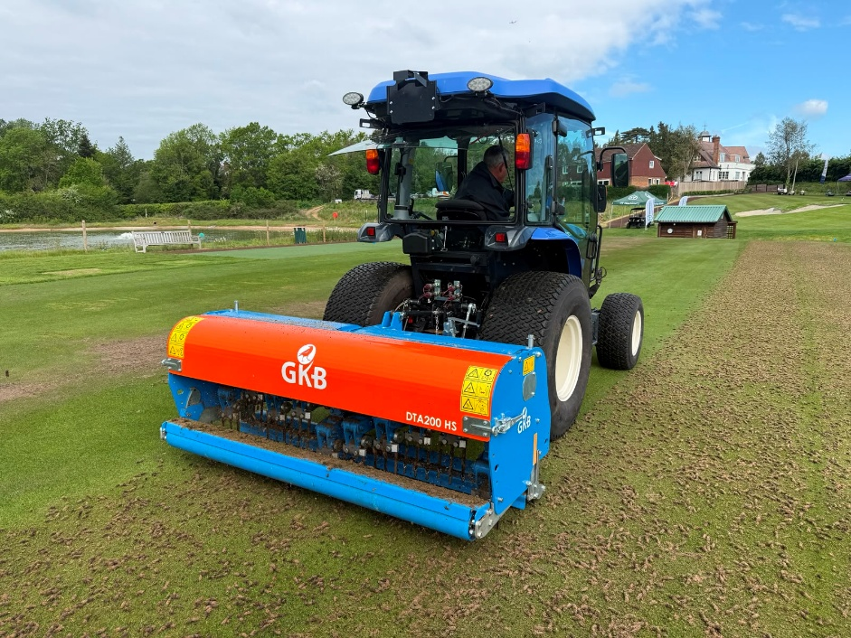
GKB Machines are set to make their GroundsFest debut this September, promising a showcase of robust maintenance solutions for natural and artificial surfaces on stand OSA80. Visitors can expect to see the newest addition to the aeration portfolio – the Deep Tine Aerator High Speed (HS) – alongside a selection of brushing and cleaning equipment trusted by facilities around the country to keep synthetic surfaces in first-rate condition.
The Deep Tine Aerator HS combines the very best of GKB precision engineering with simplicity of use and significantly enhanced speed of operation, helping turf managers to deliver all-important compaction relief while reducing surface downtime. Ideal for those working to increasingly time-sensitive schedules, the Deep Tine Aerator HS is available in 1.2m, 1.6m and 2.0m working widths and features a two-speed gearbox to effortlessly switch between slower, deep aeration to depths of 250mm (10”) and fast, shallow aeration in the top 100mm (4”) of the profile.
As with the regular Deep Tine Aerator, the High Speed model features front and rear rollers, optional hold-down plates for enhanced control and performance even on undulating terrain and a range of tine options to suit surface requirements around the maintenance calendar.
From the artificial portfolio, the recently redesigned GKB Deep Clean promises to be another stand highlight. The next generation synthetic cleaner was introduced in direct response to growing concern around microplastic pollution, featuring different sieve options and effective dust extraction system to suit different infill types and collect even the smallest contaminants and particles from artificial pitches.
As the name suggests, the Deep Clean penetrates deep into the infill layer to lift and return cleaned infill back into the surface – restoring the technical characteristics and delivering a cleaner, safer and more presentable pitch in just one pass.
With autumn renovations and preparations for winter on the cards, the GKB Technical Team will be on hand to answer all of your maintenance and machinery questions, so be sure to say hello when GroundsFest returns to Warwickshire’s Stoneleigh Park this September.
ENDS

