DLF shine a spotlight on sustainable seed solutions at GroundsFest 2026

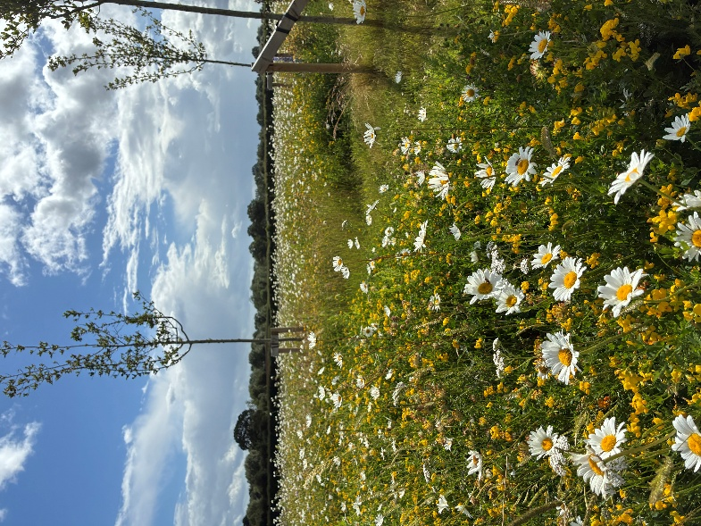
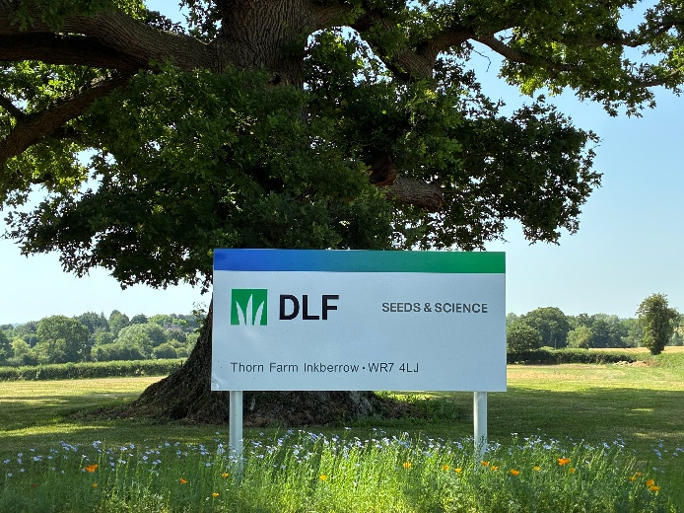
DLF, the world’s largest grass seed breeder, is set to return to GroundsFest this September with a showcase of sustainable, resilient and high-performance seed solutions for turf and landscaping professionals. Alongside the opportunity to meet the DLF Technical Team, visitors to stand 30 will be able to explore the newest additions to the Masterline, MM and Johnsons Sports Seed ranges alongside discovering the biodiversity benefits offered by the company’s Pro Flora and Colour Boost wildflower collections.
With the continued and increasing challenges posed by the climate, changing maintenance requirements and ever higher environmental expectations, DLF’s extensive collections remain committed to delivering seed solutions that combine outstanding performance, durability and sustainability.
Turf managers, contractors and conservationists looking to enhance biodiversity and increase visual merit can find all of the answers to wildflower seed selection on stand 30 this September. With more than 25 carefully constructed mixtures available across the Pro Flora and Colour Boost collections and extensive in-house production ensuring exceptional seed purity, DLF offers both the product and expertise to support your next project.
New to the UK native Pro Flora range in 2026 is Pro Flora 17. Blending moisture tolerant grasses and native flowering varieties, this moisture-tolerant mixture is ideal way to deliver ecological uplift to situations like swales, infiltration basins and multifunctional wetland landscapes. Whether the goal is establishing species-rich native meadows, creating habitats for wildlife or delivering striking visual impact with non-native annuals, DLF have the right mixtures and all the practical advice you need to achieve your ecological objectives.
Another key focus on the stand will be DLF’s 4turf tetraploid ryegrass technology. Renowned for its rapid establishment, excellent visual quality and unbeatable wear tolerance, 4turf continues to deliver proven benefits across both sports and landscaping applications. Thanks to enhanced root development, mixtures containing 4turf – such as Johnsons J 4turf range and PM51 Greenscape from Masterline – are better equipped to withstand environmental stresses such as drought and cold. The technology also delivers improved disease resistance, helping to reduce reliance on chemical inputs while supporting healthier, more resilient surfaces.
Discover all the latest advances in seed innovation by visiting DLF at GroundsFest this September, when it returns to Stoneleigh Park on 16th and 17th September.
ENDS

