Baroness build momentum ahead of 20-year milestone with GroundsFest appearance

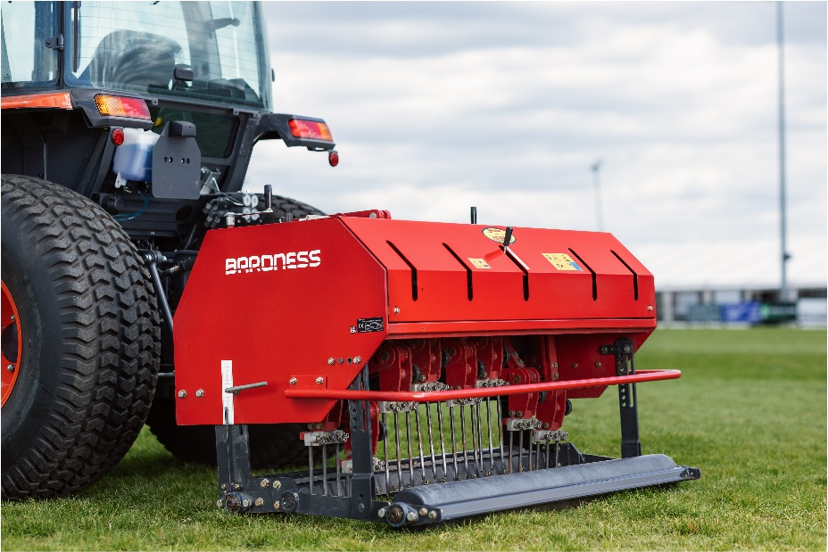
Japanese precision and engineering excellence will be the theme of stand OSA810 at GroundsFest 2026, as Baroness and Kubota team up once again to deliver a showcase of equipment critical to fine turf, groundcare and landscaping applications. Visitors can expect to see a selection of machines from the renowned Baroness mower range alongside solutions for maintenance and renovation, all backed up with the expert support of Baroness dealers – on hand to answer your questions across the two-day event.
With the 20-year anniversary of Kyoeisha UK around the corner in 2027, spirits are high for the team at Baroness. This year has seen the appointment of new dealers and an expansion of Baroness facilities, seeing the brand available from more than 45 depot locations around the U.K & E.U giving customers even easier access to a comprehensive range of quality equipment and expert local advice.
Particular highlights at Stoneleigh Park this September will include a selection of machines from the LM Series of cylinder mowers. Renowned for their samurai-sword sharp cutting heads, robust build quality and consistency of performance, the LM range finds a home in situations that prioritise productivity and pinpoint precision – equally suited to tasks on the golf course, sportsgrounds & private estates alike.
That ethos for quality extends to the Baroness turf maintenance range, including the TDA aerator and FS900 sweeper collector which will also be on display. Offering a light, compact and highly manoeuvrable solution for the quick and effective collection of cores, clippings, leaves, sand and other surface debris, the FS900 is now making a name for itself with sports facilities looking for a more convenient solution to post-match or post-renovation clean-up.
Those looking to find out more about any of the products from the Baroness mowing and maintenance range can do so with a stop by stand OSA810 when GroundsFest returns to Stoneleigh Park on 16th and 17th September 2026.
ENDS

