BAGMA to showcase bolstered member benefits at GroundsFest 2026

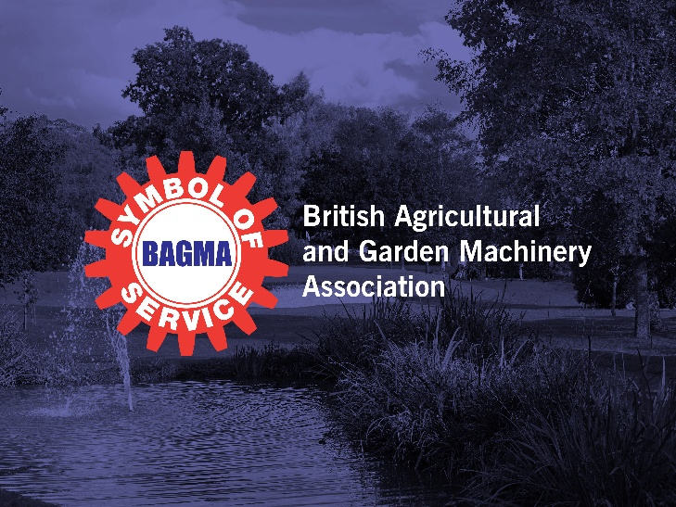
The British Agricultural and Garden Machinery Association (BAGMA) are pleased to be returning to GroundsFest in 2026, showcasing their biggest ever range of Service Providers and industry-specific training courses. In a time of continued trading and economic uncertainty, these partnerships offer genuine savings and additional value to every BAGMA membership, with current and prospective members invited to find out more on stand 39.
BAGMA have proudly supported independent garden, groundcare and agricultural machinery dealers for over 100 years – fighting for better terms and drawing on the combined strength of their membership to influence legislation and provide support in areas such as training and apprenticeships. In such volatile times, strength in numbers has never been more important, with the BAGMA team working harder than ever to compile a comprehensive range of support to deliver discounts and benefits to member businesses.
Over the last 12 months alone, BAGMA have introduced partnerships with employee benefits and insurance brokers Brown & Brown, waste management experts Avena Group, security specialists VIN Chip, business rates experts QuoinStone and international payment providers Ascendant – adding to an already comprehensive list of Service Providers offering exclusive support and discounts spanning health & safety, utilities and more.
BAGMA training has also continued to go from strength to strength, with the Off Highway Electric Vehicle & Power Equipment course – launched at GroundsFest last year – cementing its status as the industry’s leading EV training programme. With a focus on both practical skills and an awareness of legal obligations and best practice, the training has been undertaken by dealers across the country helping to raise safety standards in this rapidly growing sector of the market.
Stand 39 is also the place to learn more about the award-winning ‘Paperless Solution’ to streamline the recording of handover & installation paperwork. All of this and more can be found by speaking to a member of the BAGMA team when GroundsFest returns to Warwickshire’s Stoneleigh Park on 16th and 17th September.
ENDS

