Win with Aspen Fuel at GroundsFest 2026!

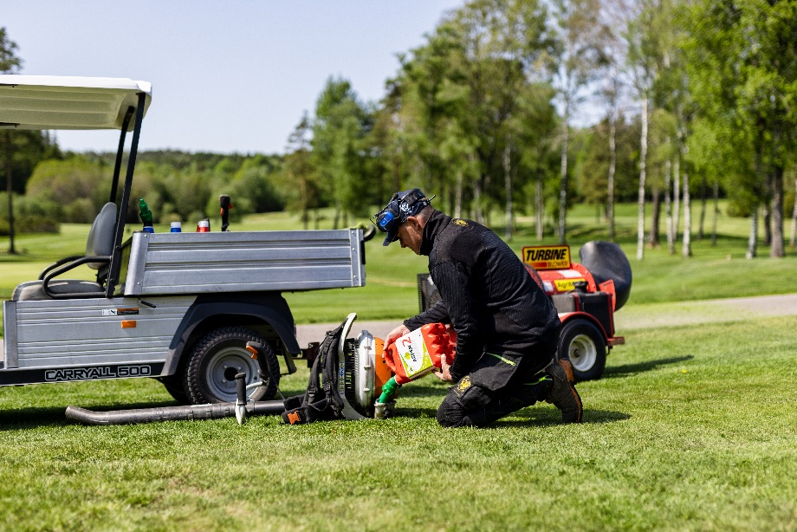
Aspen Fuel will be making a popular return to GroundsFest 2026, highlighting the significant benefits for operators, machinery and the environment of switching to alkylate petrol. The technical team will be on hand to answer all of your questions on stand H50, which is also the location to test your strength on the now infamous ‘Aspen Challenge’ – giving attendees a daily chance to win 50L of Aspen Fuel!
Unlike traditional forecourt unleaded, Aspen alkylate petrol contains virtually none of the harmful substances such as benzene and other hazardous hydrocarbons. This means operators are exposed to substantially fewer harmful fumes while working, helping to create a pleasant and healthier working environment – particularly during long periods of use or when operating equipment in confined spaces.
Not only benefitting the operator, Aspen also helps equipment perform as its best. Its cleaner composition and ethanol-free formulation promotes easier starting, smoother running and cleaner engine operation, while reducing carbon deposits which can contribute to costly servicing and maintenance. Aspen boasts an extended shelf life compared to pump petrol, eliminating many of the fuel-related issues caused by stale fuel making it ideal for seasonal equipment and machinery that may spend extended periods in storage.
Its environmental credentials are equally impressive – producing lower emissions of harmful pollutants, contributing to improved air quality for operators and those working nearby, as well as supporting more sustainable grounds maintenance practices without compromising performance.
While on the stand, attendees can also take part in a fun test of strength in the form of the ‘Aspen Challenge’ where one lucky visitor can bag themselves a free 50L drum of Aspen Fuel each day of the show.
Whether you’re already using alkylate petrol or are considering making the switch, the Aspen team will be on hand to answer questions, offer expert advice and demonstrate how Aspen can benefit your business when GroundsFest returns to Stoneleigh Park, Warwickshire, on 16th and 17th September 2026.
ENDS

