Suståne to introduce new Zero-Phos range at BTME 2026

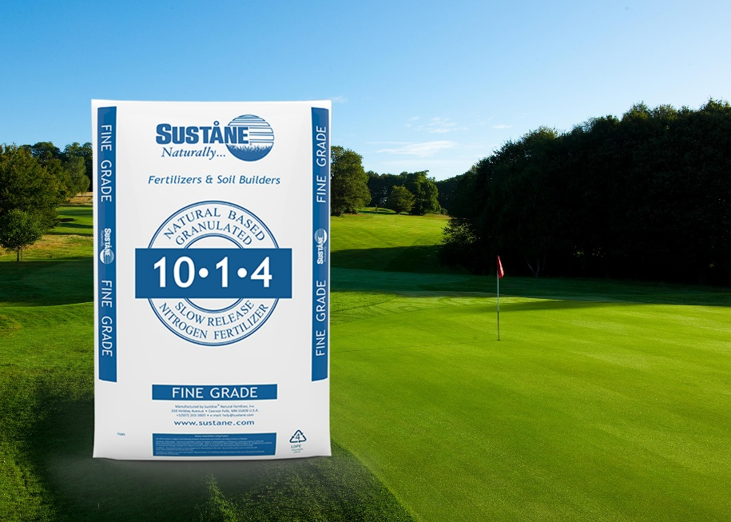
With thoughts turning to the new season, turf professionals looking for solutions that deliver early strength, reliable performance and long-term soil health can find all of the answers on the Suståne stand at BTME 2026. Featuring 75% water soluble nitrogen, Suståne’s 10-1-4 is an ideal spring starter, delivering a quicker N response in cooler weather and the necessary organic base to get spring growth off to the best start.
Suståne 10-1-4 is a fine grade fertiliser for greens, tees and tight cut fairways, rich in quick release water soluble nitrogen (WSN) making it ideal for a quick green up when soil temperatures are below optimum. While the WSN offers immediate energy, the fertiliser’s natural organic base of humus-rich compost, beneficial microbiology and all 17 elements essential for plant photosynthesis builds a stable platform for good soil structure and consistent nutrient release as temperatures rise.
Stand 170 will also see the launch of Suståne’s new Zero-Phos range of natural base fertilisers - developed to allow turf grass managers to design nutrient plans for environments where phosphate application is restricted due to local or regional regulations, or agronomic situations where phosphate application is not required. Like all Suståne fertilisers, this range is built upon the finest base of composted ingredients co-granulated with mineral nutrient inputs. The final product offer a homogenous granular fertiliser, with each granule containing essential plant nutrients, stable organic matter, beneficial biology and humic substances. This new range is easy to apply, safe and agronomically effect, and the perfect input to promote healthy turf grass and healthy, biologically active soils.
Visitors can be among the first to learn about the two new Zero-Phos fine grade formulations – 4-0-6 and 8-0-6 100SGN – and one medium grade formulation, 14-0-6 200SGN, by speaking with Suståne’s technical team when BTME returns to the Harrogate Convention Centre on 20-22 January 2026.
ENDS

