PRESS RELEASE

Kubota to showcase high-cut capability with FC4-441 at BTME 2026
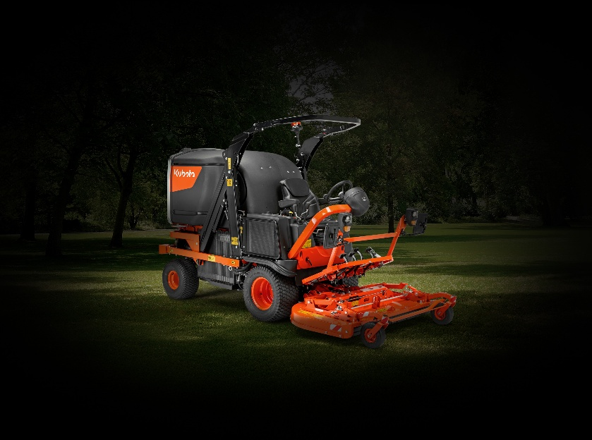
Kubota is set to make a popular return to BTME, once again partnering with Baroness to showcase a reliable and powerful portfolio of Japanese turf maintenance solutions on stand 624. The focus for 2026 is innovation in their out-front mowing range, with the FC4-441 fitted with a deck offering an impressive height of cut up to 7” taking centre stage.

The FC4-441 is the latest addition to the FC mower range, designed to deliver versatile cutting performance on large areas such as parks and sports facilities. Equally at home on the golf course, the FC4-441 will be presented at BTME with a new out-front rotary cutting deck, capable of the higher heights of cut required for heather management, wildflower maintenance or the preservation of wildlife areas and longer roughs.

While the updated deck delivers improved performance in longer or more delicate vegetation, with a quick and simple adjustment the FC4-441 can cut other peripheral areas around the course – offering greenkeepers flexibility without compromise on cut quality or productivity – or even be used as a leaf collection unit thanks to its generous 1300L hopper.

No Kubota stand is ever complete without a compact tractor or two, with both the B2-261 and L2-452 making an appearance in Harrogate this January. Renowned for its power-to-size ratio, comfort and adaptability, the B2-261 is a popular choice with golf courses across the country. Meanwhile, the L2-452 combines robust, reliable technology with a high degree of operator comfort – providing 45hp of manoeuvrable performance for all mainstream maintenance tasks.

One of those tasks is aeration, with the L2-452 equipped with the Baroness TDA aerator showcasing the epitome of a productive partnership.

Visitors to stand 624 can also ask their questions to the Kubota technical team, who will be on hand across the three days to advise how these machines and others can support more efficient and sustainable golf course management.

ENDS

About Kubota Corporation
Kubota has been a leading manufacturer of agricultural equipment, construction equipment, lawn mowers and industrial engines since 1890. With its global headquarters in Osaka, Japan, offices in more than 120 countries and more than 41,000 employees in North America, Europe and Asia, Kubota had a turnover of $20 billion in 2021. Although agricultural, construction and turf equipment are its main product lines, Kubota also produces a wide range of products such as city water purification systems, irrigation systems, piping systems, roof and home construction, and large underground valves.

Our Mission
Our mission "For Earth, For Life" speaks to our commitment to the conservation of the environment while aiding the production of food and water supplies, which are vital to meet the needs of our society, as the world’s population continues to grow. This mission is accomplished every time a Kubota tractor harvests the land to produce food or when our construction equipment excavates to transport water or provide shelter.

For more information about Kubota, visit www.kubota-global.net / www.kubota-eu.com /
Explore the Kubota Group Solutions Hub: https://kubota-group.eu

For further information please contact:

Charlotte McFarland, Tactical Marketing Executive,

Kubota (UK) Ltd, Dormer Road, Thame, Oxfordshire OX9 3UN

Tel: +44 (0)1844 214500

E-mail: charlotte.mcfarland@kubota.com

Issued by Louise Challiss, PAN Publicity Ltd
Tel: +44 (0)1493 440047
E-mail: louise@panpublicity.co.uk
PR Ref: 12548

Date of issue: 03 December 2025



Follow us on:
Website: https://www.kubota.com , https://www.kubota-eu.com
LinkedIn: https://www.linkedin.com/company/kubota/, https://www.linkedin.com/company/kubota-in-europe/
Facebook: https://www.facebook.com/KubotaEurope/
Youtube: https://www.youtube.com/channel/UC2T6NyJ2cAvVPss9Lx7hBhQ

