DLF to deliver hands on educational experience on stand 124 at BTME 2026

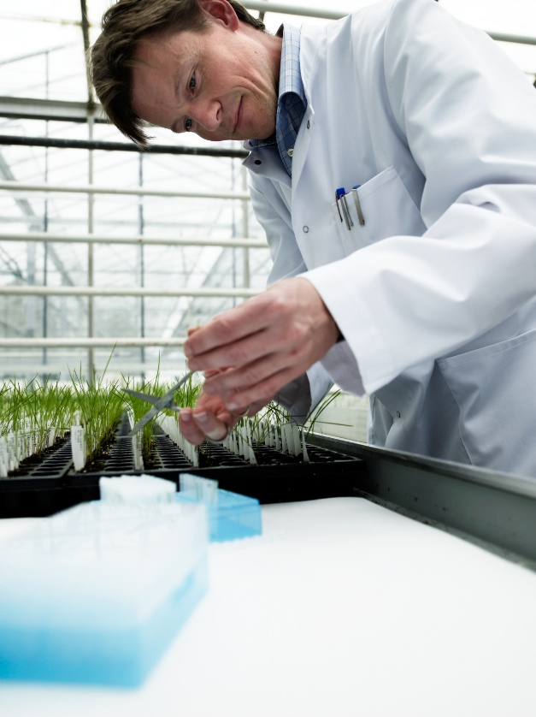
DLF Seeds are set to inspire and educate visitors at BTME 2026 with the launch of the brand new interactive ‘DLF Seed Lab’. Building on the success of previous years, the Seed Lab has been designed to bridge the gap between theory and practice – offering greenkeepers, grounds staff and turf professionals the opportunity to deepen their understanding and get hands-on with different turf grass species.
Complementing DLF’s Seed Identification Course at the Continue to Learn education programme, visitors to stand 124 will be able to see examples of managed turf and plants from key turf grass species. Seed samples and identification displays will also highlight the distinguishing characteristics of all major turf types, while live demonstrations will showcase the principles of seed quality and purity.
Together with expanding knowledge, a stop by the DLF Stand will also form part of the BASIS trail, enabling visitors to build points as part of their BTME visit.
In addition, the technical team will be discussing the latest developments in the DLF Disease Watch programme - steering cultivar and breeding programmes to develop more effective and sustainable seed solutions to tackle disease patterns across Europe head-on. One of many notable successes from this programme has been the development of DLF 4Turf tetraploid ryegrass, with improved drought and disease resistance combined with improved colour and fast establishment making them an ideal choice for turf managers looking to improve surface quality and reduce input costs.
Visitors are invited to find out more about 4Turf and all the latest updates across DLF’s market-leading Johnsons Sports Seed, Masterline and MM seed ranges together with the extensive native and high-impact wildflower collections when BTME returns to Harrogate Convention Centre on 20th to 22nd January 2026. Whether your aim to is improve your seed ID skills, explore new mixtures or be the first to learn about the latest advances in seed technology, stand 124 is one not to miss!
ENDS

