Precision meets performance as Baroness brings extensive mower line-up to BTME 2026

Baroness is set to make a commanding return to BTME 2026, showcasing the very best in Japanese engineering and turf care technology. Sharing stand 624 with Kubota once again, visitors can expect to see the full spectrum of golf course mower and maintenance solutions – all delivering the industry-leading cut quality, superior durability and long-term value the Baroness brand is synonymous with.
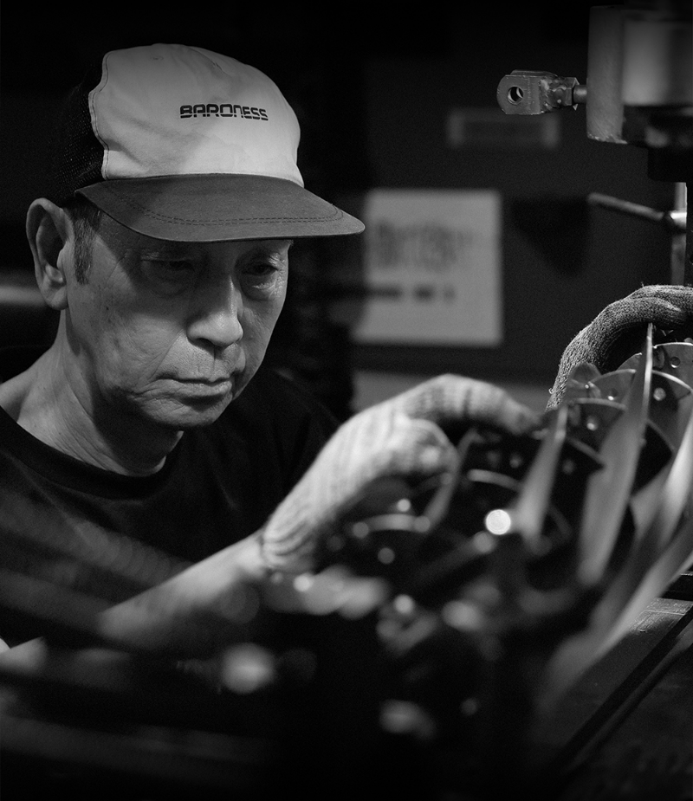
On show for the very first time in the UK or Europe will be the ELM56 – a lithium-battery powered prototype of the popular LM56 pedestrian mower. The high-capacity lithium-ion battery offers quiet, efficient operation, while the nickel-chrome-molybdenum alloy cutting cylinders with hardened bedknives guarantee a consistently professional quality of cut. Fully-gear driven for low-maintenance performance and with one-touch operation, the ELM56 provides exceptional control and manoeuvrability for a premium finish on greens, tees, tennis courts and cricket pitches.
Also making a re-appearance at Harrogate Convention Centre in January will be the LMB12. The all-electric, lightweight design of the LMB12 promises to redefine the mowing experience on steep bunker edges or ornamental areas where the compact footprint combined with ease of operation and low noise pollution is essential for optimising both presentation and safety.
Working up through the range, another highlight promises to be the LM551B – a mid-weight five-unit fairway mower which allows you to create the ideal configuration to suit your course conditions. Equipped with 22” & 26" units along with a range of optional accessories, this highly versatile machine effortlessly follows contours to maintain consistent cut quality while also delivering improvements in fuel efficiency and operator comfort.
Visitors looking for a high-output rotary mower for large spaces will also find the solution on stand 624 in the form of the five-deck GM2810A.
Complementing one of the shows biggest mower line-ups will be a number of maintenance machines including the Baroness TDA1600 aerator and Agrimetal GR660 roller. Providing an industry leading 66” roll width and equipped with the robust, low-maintenance synchro belt drive system, the GR660 enhances smoothness and playability, improving greens speed and providing a professional finish for top-tier course presentation.
Whether you’re looking to improve cut quality, increase productivity or optimise course condition, Baroness’ offering – supported by Kubota’s power units and performance – delivers the complete package from tee to green, making a stop by stand 624 a must when BTME returns on 20th – 22nd January 2026.
ENDS

