Versatile Trilo M3 takes centre stage at SALTEX 2025

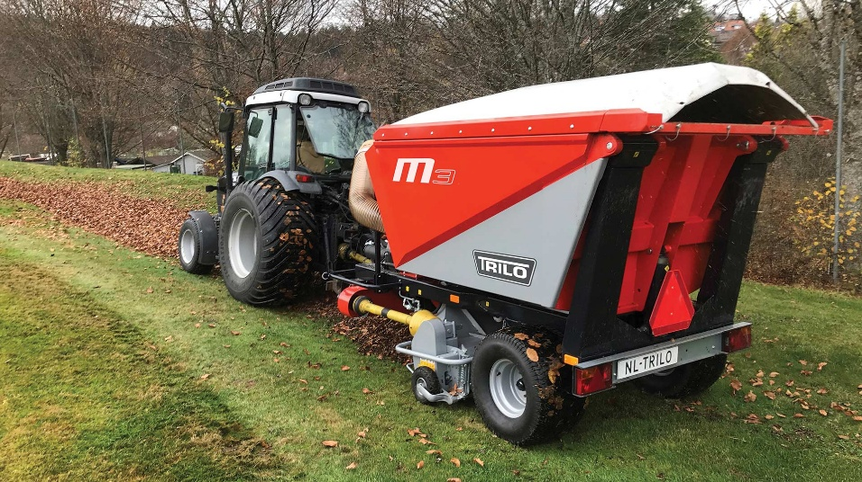
Visitors to SALTEX 2025 can be assured a showcase of market-leading, versatile vacuum sweepers with a stop by the Trilo stand, when the show returns to the NEC this November. The popular M3 from the Trilo Multipurpose range will be on display on stand B042, alongside the range of interchangeable shaft options that transforms the 3m³ collector into an all-season maintenance machine.
Renowned globally as the go-to solution for leaf and debris collection, the Trilo portfolio ranges from compact, yet capable, 3m³ units up to high-productivity 30m³ – catering for all customers and applications including local authorities, sports turf managers and maintenance around the golf course. Combining powerful suction with a smart, modular and robust construction, the Trilo M3 makes light work of removing leaves, pine needles and clippings – speeding up tasks that can otherwise dominate autumn and winter schedules.
Efficiency is further enhanced with the flexibility of a handheld wanderhose, ensuring easy collection of debris in traditionally hard to reach areas.
The variety of attachments available for the Multipurpose range means that when other vacuums are retired to the shed, the Trilo works on. A scarification shaft or flail head for large-scale cut and collect can be swapped in and out in under an hour, offering the quick and easy transition between tasks, maximising uptime and delivering further return on investment.
Collected material, be that leaves, clippings or organic matter, can then be quickly and easily emptied via Trilo’s hydraulic high-tip system.
The Trilo technical team will be on hand throughout the duration of the two days, to provide expert advice on machine selection, specification and operation. Whether attendees are looking to improve seasonal leaf collection or enhance year-round productivity, a visit to B042 will provide the chance to explore the M3 along with other solutions from the Trilo product portfolio.
ENDS

