PRESS RELEASE

Kubota to showcase ‘one stop shop’ for all groundcare professionals at SALTEX

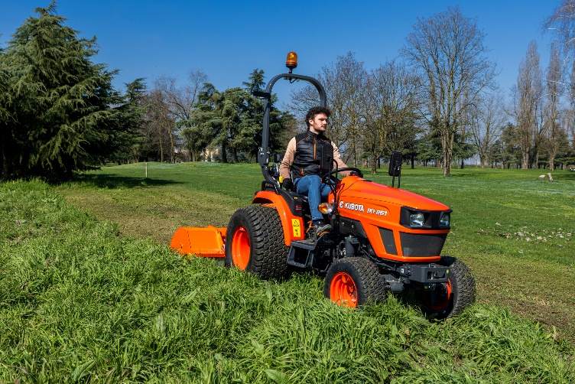
SALTEX will once again provide the perfect platform for Kubota UK to showcase a comprehensive range of professional groundcare equipment when the show returns to The NEC on the 12th and 13th November. Visitors to stand E060 can expect to find products from the RTV, compact tractor and mower portfolios, with Kubota’s expanded zero-turn range promising to be one of many highlights.

Combining exceptional manoeuvrability with first class cut quality, Kubota will be bringing not one but THREE zero-turn mowers to SALTEX! Launched last summer, the Z4-541 is a 54” petrol model which boasts outstanding versatility, ease of operation and a large chassis to deliver excellent productivity to the pro-consumer market. From the diesel range, the well-established ZD-1211 provides comfort and fast working with excellent fuel efficiency, meeting all the needs of the commercial operator.

Last but not least, the Kubota ZE-481 delivers the performance and precision required of a professional zero-turn mower, in a sustainable, battery-powered package. With zero emissions at the point of use and significantly reduced noise output, the ZE-481 allows grounds teams to work in noise-sensitive environments such as schools, hospitals and public parks without disruption.

Also taking centre stage in the SALTEX Community Sports Zone will be the Kubota EK1-261 HST. Easy to operate and built with capability in mind, the EK1-261 HST is perfectly suited to grassroots sports facilities – offering Kubota reliability and back-up support in an entry-level set-up that promises unbeatable return on investment.

Complementing these will be a selection of Kubota compact tractors and utility vehicles from the RTV range. Kubota will also be joined on stand by representatives from Terrako – Kubota’s new online ordering software for genuine parts - and Baroness, making E060 a ‘one stop shop’ for high performance power and implements suited to all applications and every grounds maintenance professional.

ENDS

About Kubota Corporation
Kubota has been a leading manufacturer of agricultural equipment, construction equipment, lawn mowers and industrial engines since 1890. With its global headquarters in Osaka, Japan, offices in more than 120 countries and more than 41,000 employees in North America, Europe and Asia, Kubota had a turnover of $20 billion in 2021. Although agricultural, construction and turf equipment are its main product lines, Kubota also produces a wide range of products such as city water purification systems, irrigation systems, piping systems, roof and home construction, and large underground valves.

Our Mission
Our mission "For Earth, For Life" speaks to our commitment to the conservation of the environment while aiding the production of food and water supplies, which are vital to meet the needs of our society, as the world’s population continues to grow. This mission is accomplished every time a Kubota tractor harvests the land to produce food or when our construction equipment excavates to transport water or provide shelter.

For more information about Kubota, visit www.kubota-global.net / www.kubota-eu.com /
Explore the Kubota Group Solutions Hub: https://kubota-group.eu

For further information please contact:

Charlotte McFarland, Tactical Marketing Executive,

Kubota (UK) Ltd, Dormer Road, Thame, Oxfordshire OX9 3UN

Tel: +44 (0)1844 214500

E-mail: charlotte.mcfarland@kubota.com

Issued by Louise Challiss, PAN Publicity Ltd
Tel: +44 (0)1493 440047
E-mail: louise@panpublicity.co.uk
PR Ref: 12487

Date of issue: 12 September 2025



Follow us on:
Website: https://www.kubota.com , https://www.kubota-eu.com
LinkedIn: https://www.linkedin.com/company/kubota/, https://www.linkedin.com/company/kubota-in-europe/
Facebook: https://www.facebook.com/KubotaEurope/
Youtube: https://www.youtube.com/channel/UC2T6NyJ2cAvVPss9Lx7hBhQ

