GKB to celebrate 10 Years in the UK at SALTEX 2025

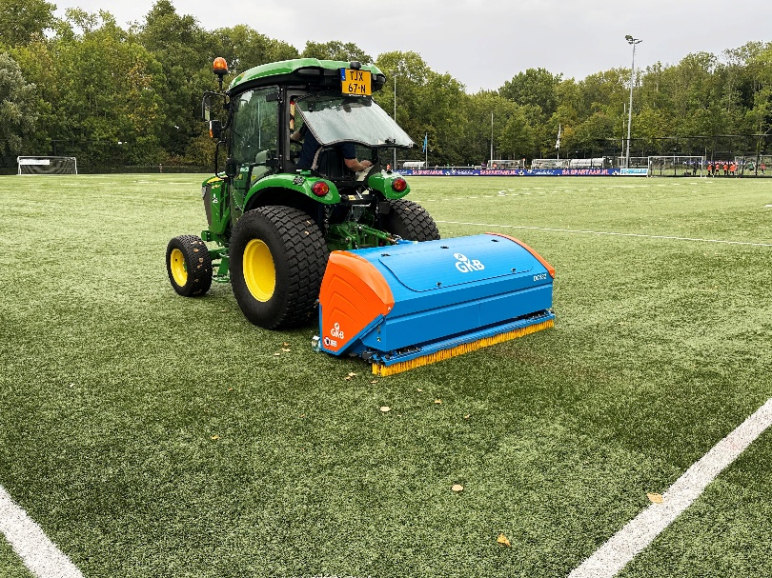
GKB Machines are pleased to be returning to SALTEX in what is a special year for the company as they celebrate 10 years of their UK operation. Stand A080 promises to encapsulate the very best of innovation, growth and partnerships from the last decade – including the new Deep Clean for synthetic surface maintenance which will be making its global debut.
While GKB Machines was founded in 1946, the dedicated UK division was only established in 2015, which makes the growth and the success of GKB in the UK grounds management industry even more impressive! Under the stewardship of Tom Shinkins, GKB has gone from strength to strength, with equipment from their natural and artificial portfolio finding homes with professionals at all levels – from grassroots facilities to elite venues around the country.
At SALTEX, one of the latest additions to that range will be on show in the form of the new Deep Clean. A core part of the GKB synthetic maintenance range for many years, the Deep Clean has been enhanced and redeveloped in collaboration with SMG. The next generation machine will be available in 1.2m, 1.5m and 1.8m working widths and will offer improved cleaning and maintenance performance on all types of synthetic surface.
Developed with grassroots facilities in mind and showcasing the very best in GKB engineering, visitors can also expect to see the GKB Combitool. Providing the perfect partnership of versatility and efficiency, the Combitool features four attachment slots which can be quickly and easily tailored to the needs of any facility. Suitable for natural and hybrid surfaces, operators can rake, roll, slit and brush in a single pass making it ideal for community clubs and smaller venues looking for professional results at an accessible price.
See the range first hand and celebrate a decade of turf maintenance excellence with the GKB Team with a stop by stand A080 when SALTEX returns to The NEC this November.
ENDS

