Baroness to showcase cutting edge solutions at SALTEX 2025

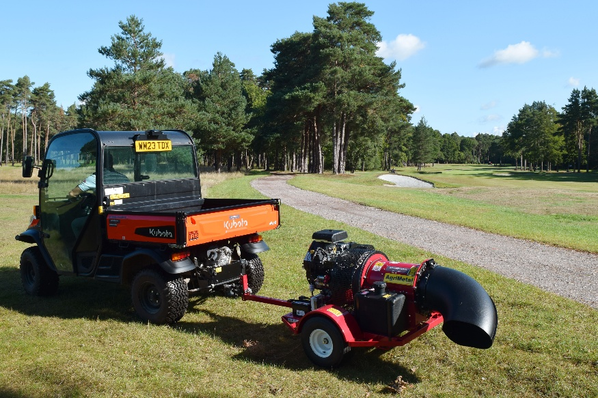
Baroness is pleased to be returning to SALTEX once again alongside Kubota, showcasing a range of cutting edge maintenance solutions on stand E060. Visitors can expect to see highlights from the LM range, including the LM551B fairway mower, LM351 triple surrounds mower and the LM56GC pedestrian mower on show alongside a range of implements from the professional Baroness maintenance range such as the AgriMetal Turbine Blower TB-270.
Renowned for precision, durability and industry-leading cut quality, the LM mower range embodies Baroness’s core values of engineering excellence, ease of operation and exceptional results. From the versatile LM551B with its outstanding contour-following capabilities, to the highly manoeuvrable LM351, turf managers can be assured a consistent cut from blades and cylinders which stay on cut up to three times longer than the competition.
The LM56GC from the Baroness pedestrian range will also be on display. Built to provide the highest quality finish on fine turf areas such as golf greens, tennis courts and cricket wickets, the LM56GC is completely gear driven – making the mower easier to maintain and more durable in operation compared to other machines that utilise belt or chain drive systems. It is also supported with an impressive five year warranty.
Besides an impressive mower line-up, Baroness will also be bringing the TB-270 Turbine Blower from AgriMetal to The NEC this November. This powerful, high-performance blower delivers maximum efficiency for leaf and debris clearance, giving grounds teams the solution to clear large areas with speed and accuracy thanks to precision airflow control.
Joining forces with Kubota makes stand E060 a platform for the very best of Japanese excellence in engineering, innovation and reliability. The two technical teams will be on hand to offer the very best support and advice to find you the perfect solution to your turf management requirements when SALTEX returns on the 12th and 13th November 2025.
ENDS

