BAGMA to highlight new industry EV training at SALTEX

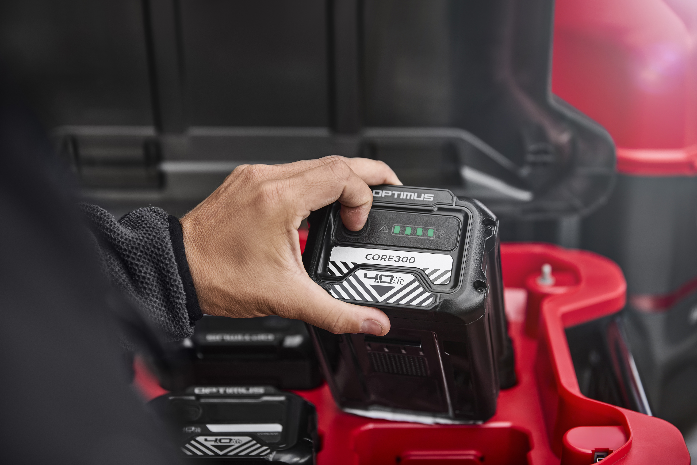
The British Agricultural and Garden Machinery Association (BAGMA) are pleased to be returning to SALTEX this November, showcasing their brand-new EV training course alongside a whole host of other member benefits. Visitors to stand A030 can discover all the latest services and savings, as well as join fellow industry members for a special networking event as BAGMA brings a one-off Connect event to The NEC!
Recognising the ongoing shift towards electric vehicles and battery-powered equipment in the groundcare industry, BAGMA have teamed up with lecturers and industry partners to develop a new, practical one-day training course that’s set to become the benchmark for those operating Off-Highway Electric Vehicles (OHEV) & Electric Outdoor Power Equipment (EOPE).
The programme is designed to help technicians, sales staff, delivery drivers, engineers and workshop personnel gain a working knowledge of the hazards of high-voltage electric systems, best practice for handling and storage of battery packs and an awareness of all relevant legislation and compliance requirements. The course concludes with a short assessment and a certificate of completion which is an increasingly valuable asset as electrification continues to take the industry by storm.
Alongside training, stand A030 will also be the place to discover the exclusive offers and savings available from BAGMA’s range of approved Service Providers. Following a year of difficult trading conditions for many, make sure you’re making the most of your membership by speaking to a member of the BAGMA team about member discounts on finance, utility contracts, lease vehicles and more.
Members are also invited to join BAGMA for a very special BAGMA Connect networking event at SALTEX 2025. Join your peers, industry partners and a selection of BAGMA Service Providers for a drink in The Clubhouse from 3pm on Wednesday 12th November.
ENDS

