DLF return to GroundsFest with futureproofed solutions for green spaces

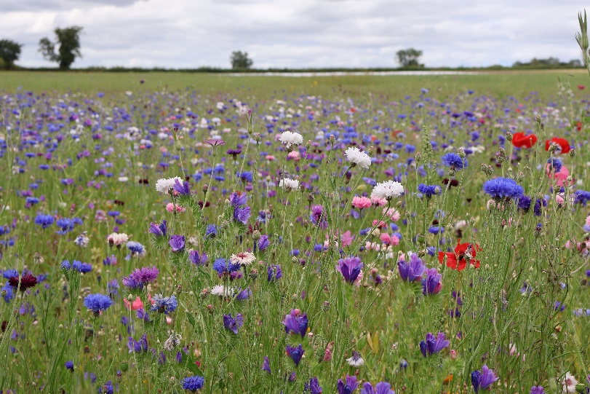
The world’s largest grass seed breeder, DLF, return to GroundsFest this September, with a renewed focus on resilient, sustainable and high-performance seed solutions for the evolving demands of turf and landscaping professionals. The technical team will be on hand on stand 30 to showcase all of the developments across the Masterline, MM and Johnsons Sports Seed ranges, together with discussing the biodiversity benefits of their Pro Flora and Colour Boost wildflower collections.
With climatic conditions and maintenance demands placing ever-increasing pressure on turf managers, DLF are pleased to present their strongest ever line-up of grass seed mixtures to support durable, sustainable surfaces without compromising on plant health or visual merit. Central to this offering is DLF’s 4turf® tetraploid ryegrass technology.
Proving itself to be a game-changer for elite sporting venues, 4turf® is also well suited to landscape applications where rapid establishment, visual quality and a hardwearing surface are of paramount performance. With enhanced root development, mixtures that contain DLF’s 4turf® tetraploid ryegrass - such as Johnsons J 4turf 25/50/100 and PM51 Greenscape from the Masterline range - are better equipped to withstand environmental stresses such as drought, cold and wear. Hardier in nature, 4turf® also demonstrates better disease resistance, reducing reliance on chemical applications.
Further environmental benefit is delivered by DLF’s Pro Flora and Colour Boost wildflower ranges. With more than 25 mixtures available and significantly expanded in-house production for enhanced seed purity, DLF offers both the expertise and capacity to support conservation and biodiversity initiatives in all settings across the UK. Whether the objective is to creative native, habitat-rich meadows, or deliver bold visual impact with non-native annuals, there’s a mixture suited to every environment.
DLF’s experts will be available throughout the event to answer all of your technical questions as well as discuss the comprehensive research and trials programme underway at their industry-leading headquarters in Inkberrow, Worcestershire. Discover the next generation of sustainable, high-performance green spaces with a visit to DLF when GroundsFest returns to Stoneleigh Park on the 9th and 10th September.
ENDS

